Restricted and Non-Sensitive



|  |  |
| --- | --- |
|  | 2024/2025 SEMESTER 1 – ASSIGNMENT 1 |
| Course | : Diploma in Information Technology |
| Module | : IT3663 –Cyber Security Attack & Defence |

Jun 2024



**INSTRUCTIONS TO CANDIDATES**

1. Complete all questions and sections of this assignment.

1. Submit your answers to this assignment using the Assignment Folder (BrightSpace) in **PDF** format only, do not submit in any other format!

1. Assignment deadline is according to the broadcasted date/time in the BrightSpace announcement.

1. You are expected to do self-learning using **Google** and **Youtube** on how to use the suggested tools to break into the user accounts.

1. Section A of this assignment should not exceed more than 12 hours of your time.

1. The skills learned from this assignment **must not** be applied to any live servers without explicit permission from the owners!

1. Good luck!

**SECTION A (50 Marks)**

**(ANSWER ALL QUESTIONS)**

For this section A, make sure your signed onto ‘Hack The Box’ cyber-range. Show all steps with **screenshots**.

Question 1

Obtain the flag found on the machine called ‘**Fawn’**.

Using **Nmap**, scan this machine and list the network services running on it.

*The command nmap -sC -sV [target ip] is used to scan and list the network services running on it*

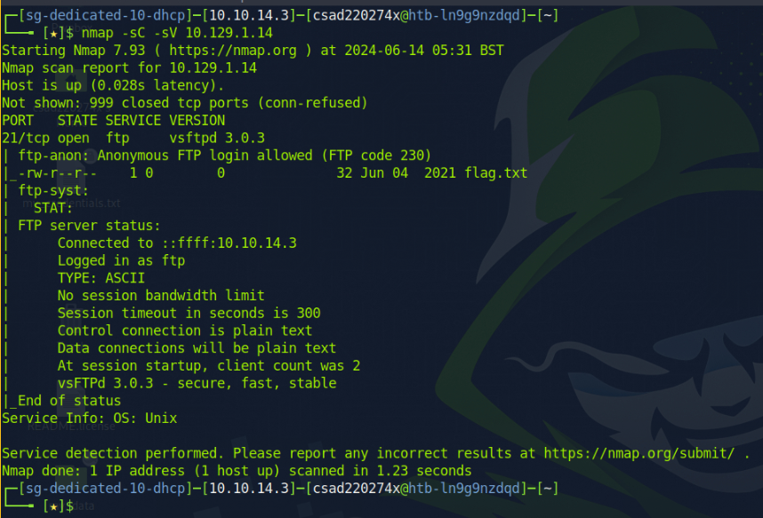

( 1 mark )

Obtain the value of the flag.

*Based on the screenshot, FTP (port 21) is running and open on the target machine that allows for an anonymous login.*

*To take advantage of it, the command ftp [target ip] is first done to access the server. Upon asking for credentials, the username would be ‘anonymous’ without any password entered.*

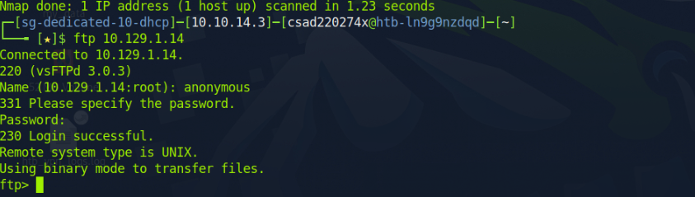

From there, a ‘ls’ command is done to view any possible directories to only see the flag.txt file inside. A ‘get flag.txt’ is done to extract the file onto the attacking machine before doing ‘cat flag.txt’ to read its contents.

The flag for Fawn is : 035db21c881520061c53e0536e44f815

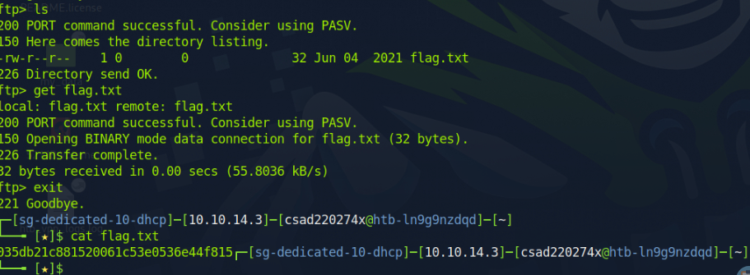

( 4 marks )

Question 2

Obtain the flag found on the machine called ‘**Tatics’**.

Using **Nmap**, scan this machine and list the network services running on it.

*The command nmap -sC -sV [target ip] is used to scan and list the network services running on it. However, a message shows that the host seems down and possibly blocking ping probes. To circumvent this, the -Pn argument is added to the nmap command. This skips host discovery, assumes it is up, and begins the port scanning process.*

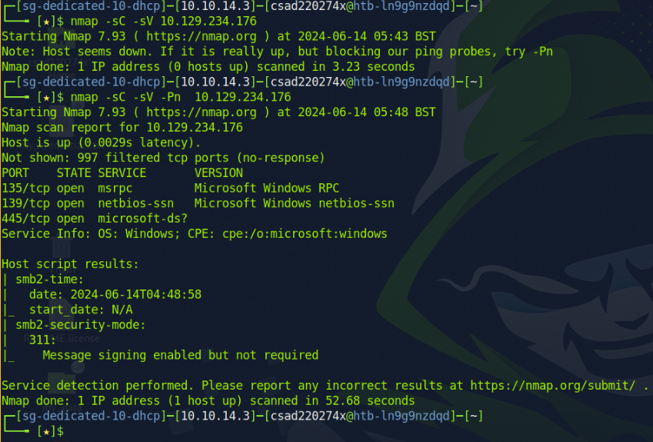

( 1 mark )

Obtain the value of the flag.

*From the screenshot, the notable open ports are 139 and 445. This indicates that we can use smbclient to gain access to it. Next, enumeration is done with ‘enum4linx’. Immediately, we can see that the known usernames of the target is ‘administrator’, ‘guest’, ‘root’, etc.*

*Unfortunately, the information of the shares isn’t disclosed with enum4linux -S, so smbclient -L is used instead. On the first attempt, smbclient -L [target ip] is used assuming credentials aren’t needed, only get an error. This is where the administrator username obtained prior is used with success.*

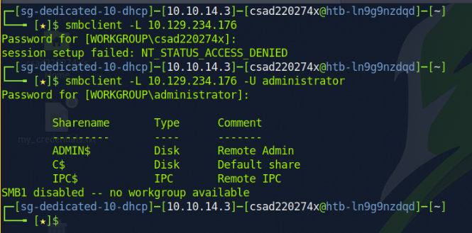

*From there, the respective shares are tested for a successful login. ADMIN$ did not yield anything meaningful, so the C$ was tested with success. Navigation into it led to the discovery of the Administrator’s user folder.*

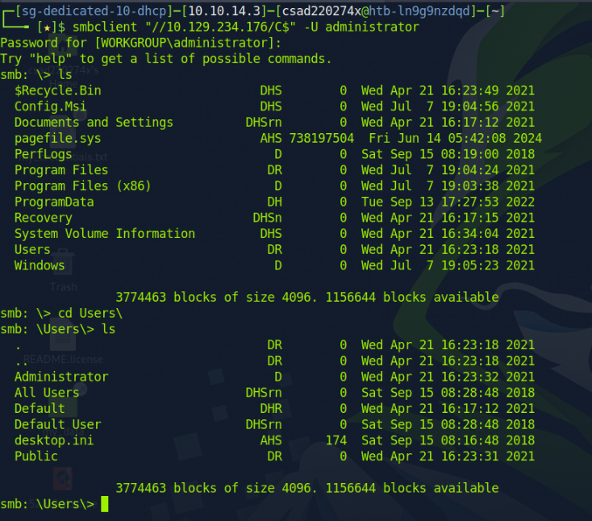

*Upon entering the Administrator’s user folder, the directories were searched and a ‘flag.txt’ file was discovered in their Desktop. A ‘get flag.txt’ command was done to extract the file to the attacking machine. To read the flag, the ‘cat flag.txt’ was used and the flag was obtained.*

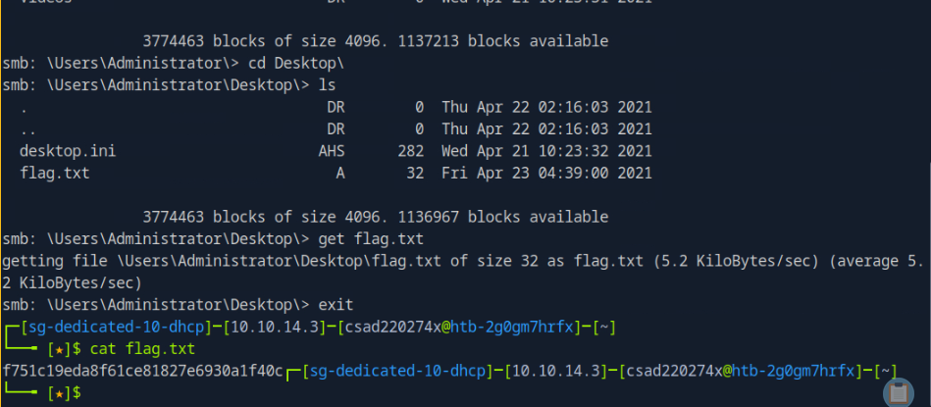

*Flag of Tactics: f751c19eda8f61ce81827e6930a1f40c*

( 4 marks )

Question 3

Obtain the flag found on the machine called ‘**Preignition**’.

Using **Nmap**, scan this machine and list the network services running on it.

*The command nmap -sC -sV [target ip] is used to scan and list the network services running on it*

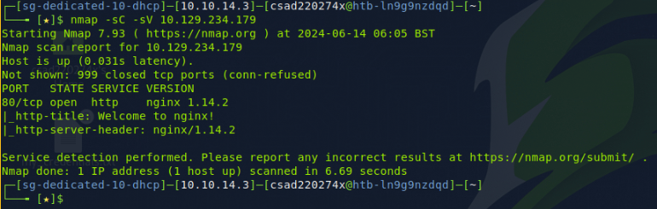

*This shows of port 80 (http) being open and running an nginx server*

( 1 mark )

Use **Nikto** to scan for probable weak links. List them.

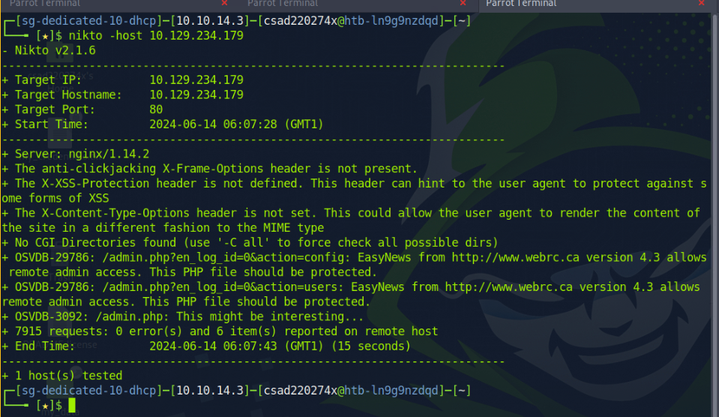

*From Nikto’s output, the weak link found was the admin.php file. As the target machine is running an nginx server, its ip address is entered into a browser. Then the /admin.php is appended to that url, giving a login page:*

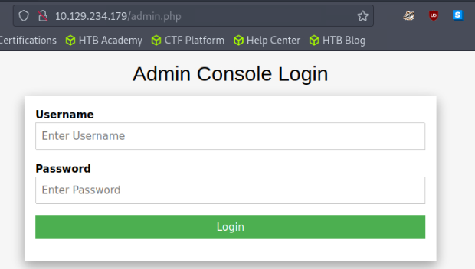

( 1 mark )

Taking advantage of the weak link and using ‘**Hydra**’, obtain the value of the flag

*Given that it’s a login page, credentials would be needed to gain access. The first discovery was the ‘nginx is successfully installed and working.’ page.*

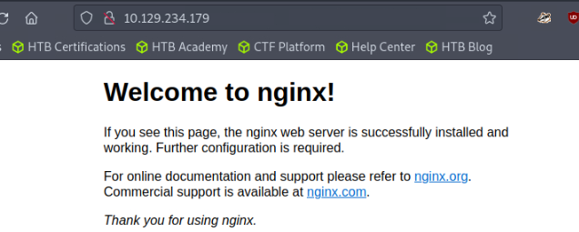

*It also adds that further configuration of the service is required. Therefore, with any new service being set up, there is a good chance of default credentials being available.*

*And with a quick online search, the following is found:*

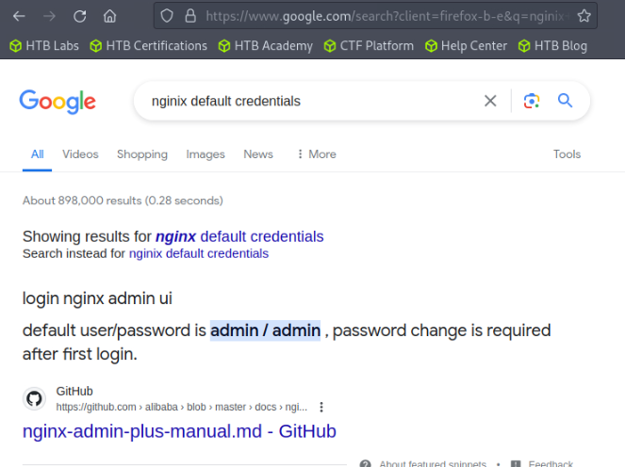

***However, with Hydra needing to be used, it is assumed that only the username has been discovered.***

*The use of brute force requires a file of passwords to reference from on each login attempt. In Hack The Box, this common passwords file is called rockyou.txt, and can be found in the /usr/share/wordlists/ directory.*

*The command ‘****hydra -l admin -P /usr/share/wordlists/rockyou.txt [target ip] http-post-form '/admin.php:username=^USER^&password=^PASS^:Wrong username or password****.' is used.*

*-l indicates the username to be tested, and -P specifies a file to be ran through for possible passwords. ‘http-post-form’ states the method used by the form, admin.php is the file to be tested. ‘username=^USER^&password=^PASS^’ are the parameters that are going to be entered into the form. And the return statement of wrong username or password is the message of a failed attempt.*

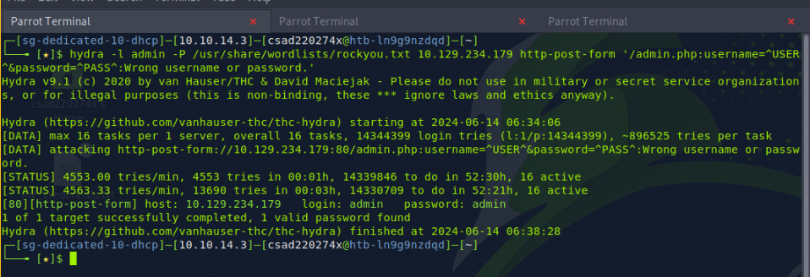

*A password has been found that’s associated with the username admin. It is ‘admin’.*

*With this knowledge, the credentials are entered into the admin login page:*

*Username: admin*

*Password: admin*

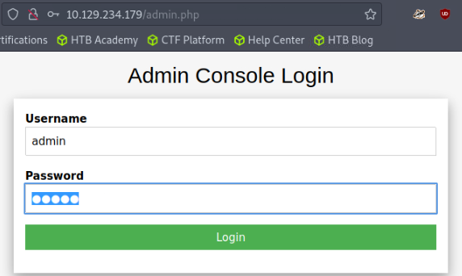

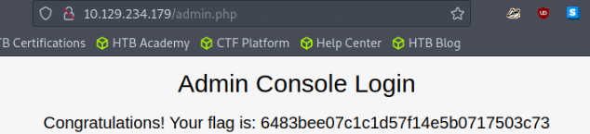

The credentials are correct and access into the admin console has been gained.

Flag of Pre-Ignition: 6483bee07c1c1d57f14e5b0717503c73

( 3 marks )

Question 4

Obtain the flag found on the machine called ‘**Dancing’**.

Using **Nmap**, scan this machine and list the network services running on it.

*The command nmap -sC -sV [target ip] is used to scan and list the network services running on it*

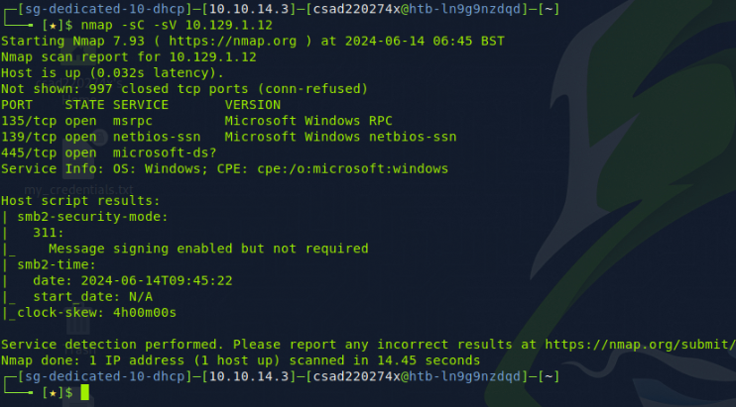

( 1 mark )

Obtain the value of the flag

*From the screenshot, ports 139 and 445 are open, indicating that SMB is running. From here, the ‘smbclient -L [target ip]’ command can be used to obtain the shares.*

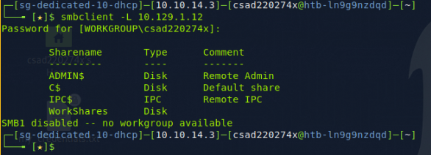

*This successful discloses of the 4 (WorkShares included) shares of the target machine. Now, each share was tested for a null session, a test case where both username and password weren’t required. Of all that were tested, only ‘WorkShares’ was successful in this.*

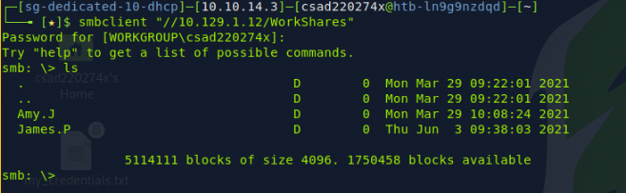

*In WorkShares, there are 2 users, Amy.J, and James.P. These directories were explored, and the ‘flag.txt’ file was discovered in the James.P directory. The file was extracted using ‘get flag.txt’ and read in the local machine using ‘cat flag.txt’.*

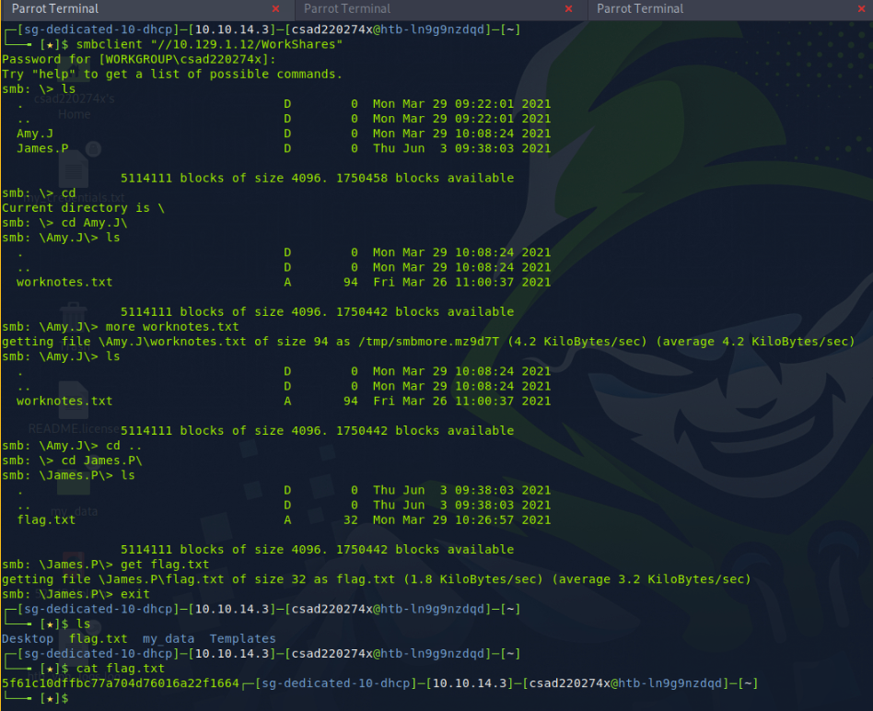

*Flag of Dancing: 5f61c10dffbc77a704d76016a22f1664*

( 4 marks )

Question 5 (Challenge Question)

Obtain the flag found on the machine called ‘**Caring**’.

Using **Nmap**, scan this machine and list the network services running on it.

Ports 135, 139, and 445 are open. Port 445 is for SMB.

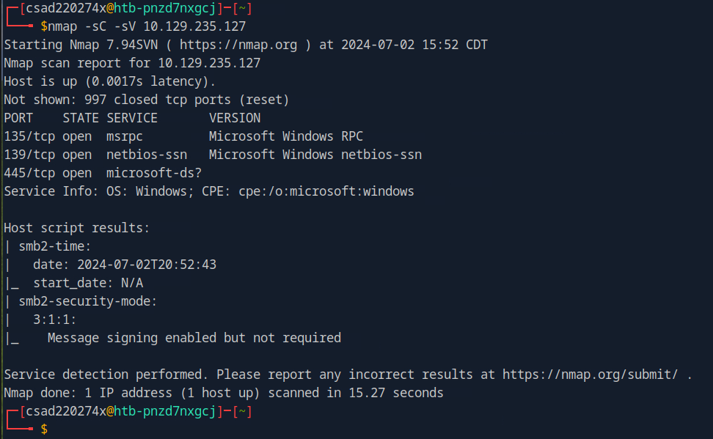

( 1 mark )

Obtain the value of the flag

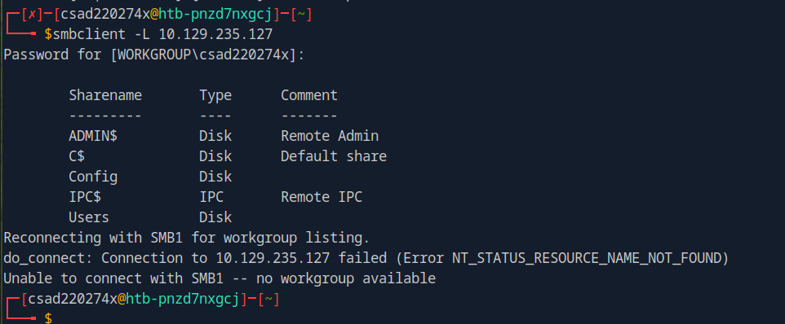

smbclient is used to view available file shares and each will be viewed until useful information can be discovered.

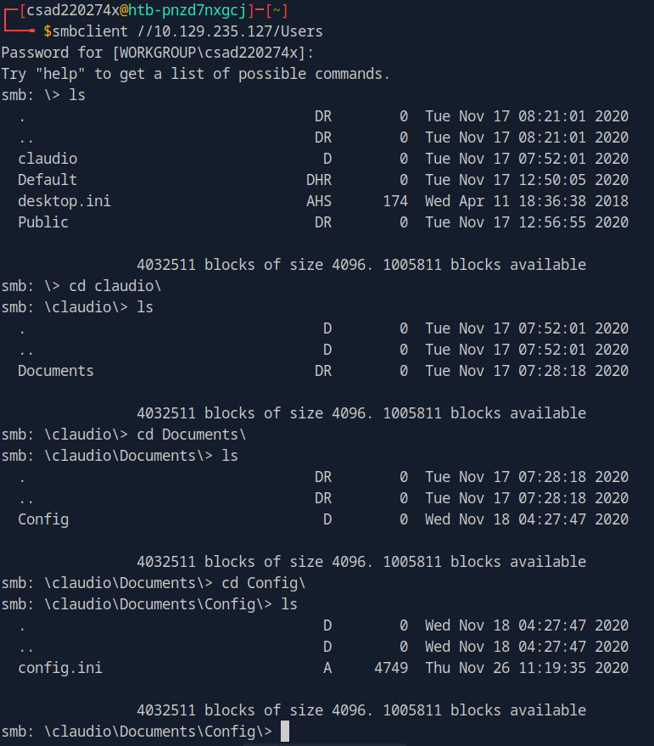

The ‘Users’ share contains a user called claudio whose console history can be viewed. The Config.ini file contains configuration and initialization details, which includes login credentials.

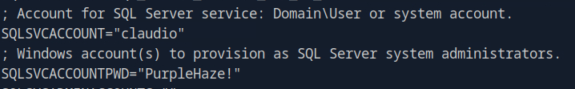

Now knowing the username and password, evil-winrm (Windows Remote Management) is used to gain access into the claudio account as it is a Windows machine.

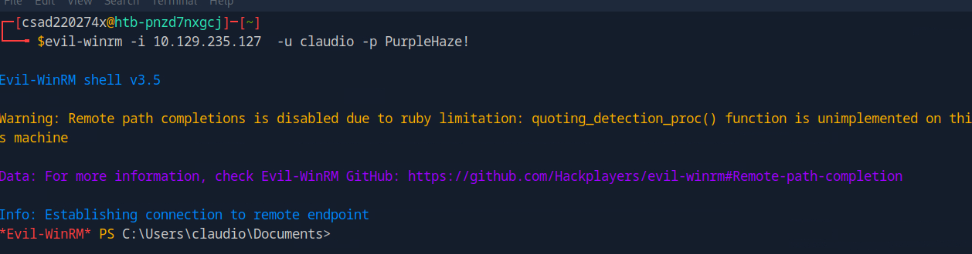

Next, the command ‘ cd $env:APPDATA\Microsoft\Windows\PowerShell\PSReadLine\’ is used to get to the directory where the powershell history file is located. This file is useful as it contains the user’s input from past sessions into a file. This can include credentials which are really useful in possibly escalating privilege.

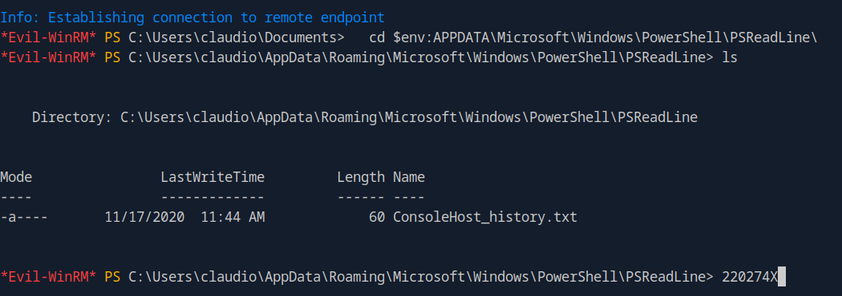

Now a simple ‘cat ConsoleHost_history.txt’ is done to view its contents:



With credentials of an administrator, this time we’ll use evil-winrm and login as an administrator.

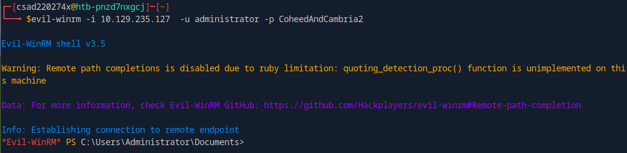  
Once in, we’ll go the Users\ directory:

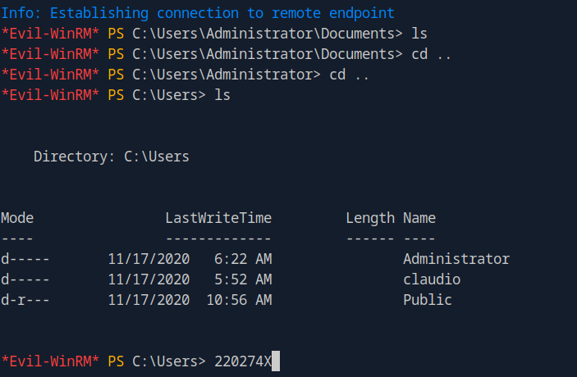

With all possible users known, the directories are explored to obtain the flags.

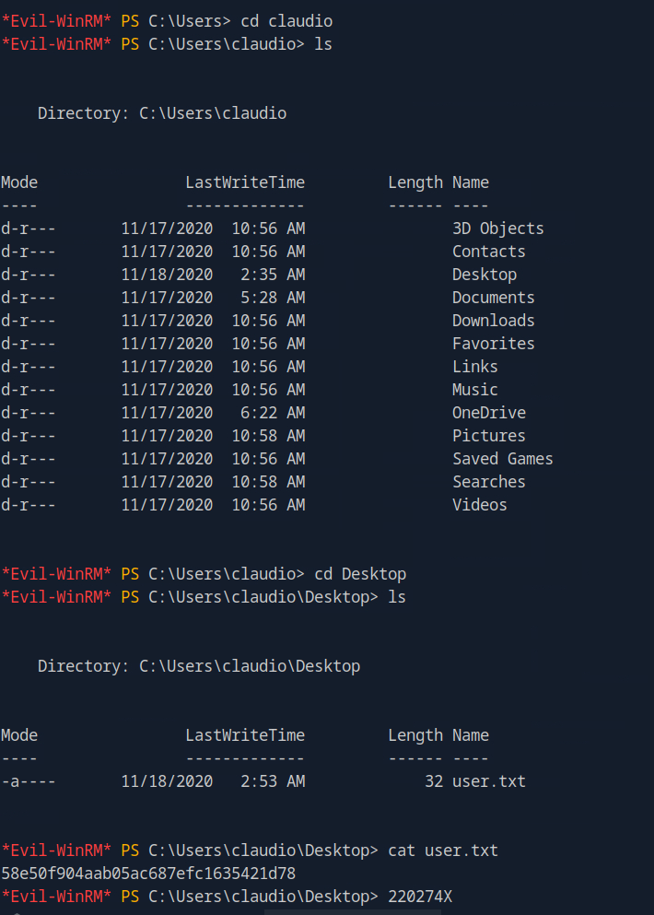  
 The first discovery was claudio’s flag: 58e50f904aab05ac687efc1635421d78

And the second discovery was the main flag, the administrator flag:

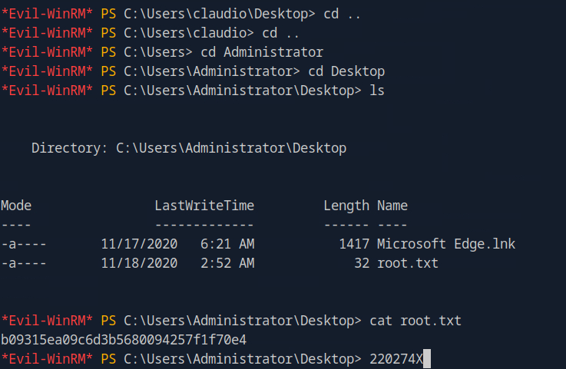

Administrator flag: **b09315ea09c6d3b5680094257f1f70e4**  
  
 ( 9 marks )

Question 6 (Challenge Question)

Obtain the passwords found on the machine called ‘**Timelapse**’.

Using **Nmap**, scan this machine and list the network services running on it.

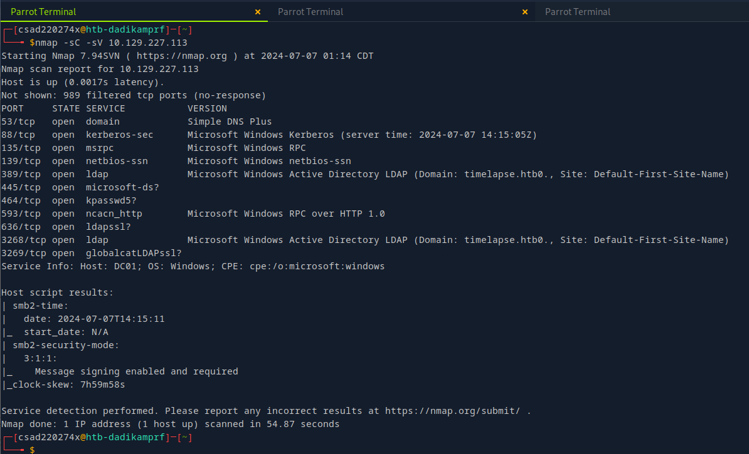

*nmap -sC -sV [target ip] is first used to obtain the open ports of the machine. Port 445 being open means that the SMB service will be explored.*

( 1 mark )

What is/are the available Windows File Share(s) available from Timelapse?

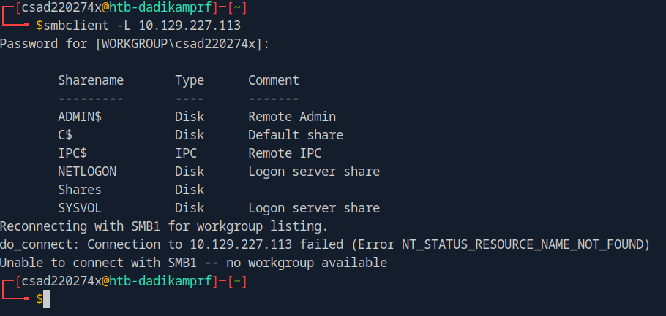

*The following file shares are obtained using smbclient -L [target ip], and gives:*

* *ADMIN$*
* *C$*
* *IPC$*
* *NETLOGON*
* *Shares*
* *SYSVOL*

*The file share that was accessible through a null session was ‘Shares’:*

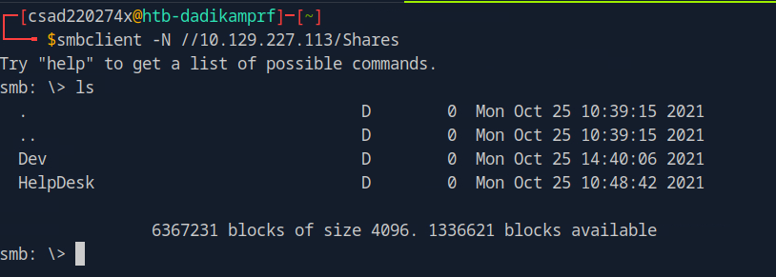

*The Dev directory is explored where a winrm zip file is present which is then obtained:*

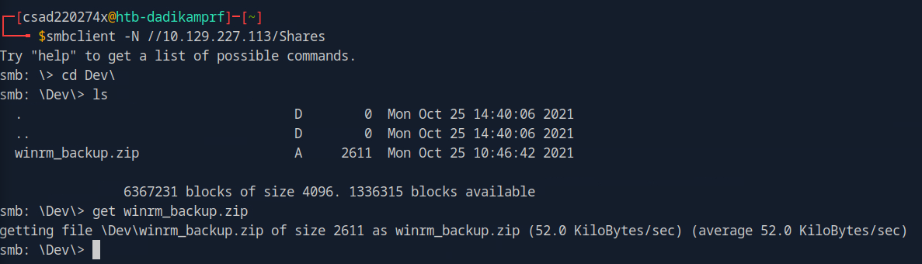

( 2 marks )

Obtain the value of password used to protect the ZIP file available from one of the Shared Folders. Hint: Use ‘John the ripper’

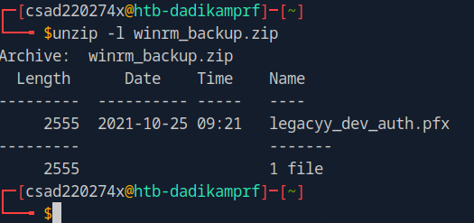

*By using unzip -l, the contents of the zip can be examined, and .pfx files contain both a private and public key for a user. If the file can be accessed, remote access to the victim’s machine with those credentials can be done.*

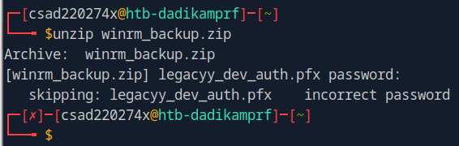

*Attempts to unzip the file requires a password. Brute forcing can be done to obtain the password through John the Ripper.*

*The first thing to be done involves creating a hash for the brute force attempt to have something to reference to:*

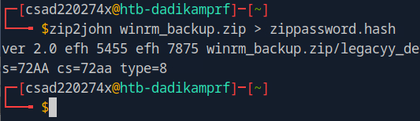

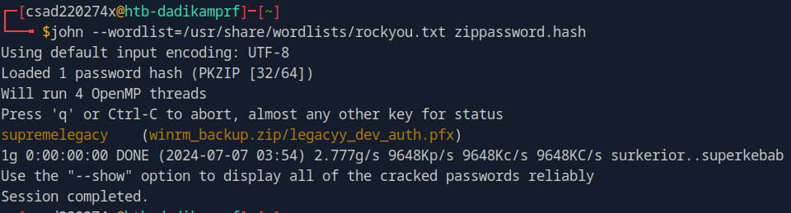

*Using John the Ripper, it uses a wordlist from the /usr/share/wordlists/ directory, and a file called rockyou.txt. The text file contains a list of common passwords, and through testing the hash values against zippassword.hash file, the password ‘supremelegacy’ is the one that allows unzipping of the file.*

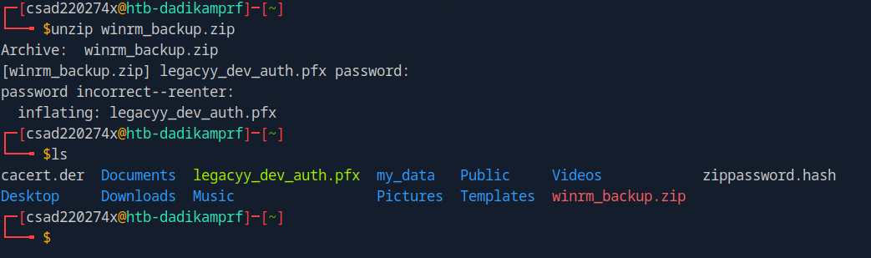

*After entering the cracked password, the zip file is successfully unzipped with the .pfx file now visible in the user home directory.*

( 3 marks )

Within the ZIP file contains another file ending with extension of PFX. Try to obtain the PFX key of this file. Hint: Use ‘John the ripper’

*As mentioned, .pfx files contain information about private and public keys. As such, they’d need to be extracted. However, the extraction requires a password as seen:*

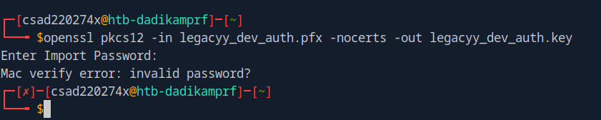

*-in represents the input, which is the .pfx to be extracted, while -out is the output, which are the keys within the file. Due to a password being required, John the Ripper is used again to brute force for a password.*

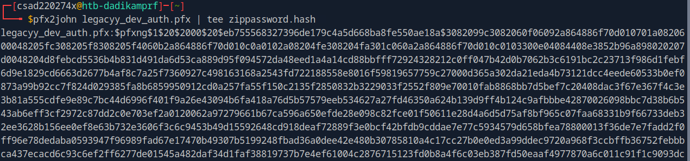

*Like the previous password cracking question, a hash is created prior to brute forcing. This time, pfx2john is used given the file type of .pfx. With the hash created, John the Ripper is used and the rockyou.txt list of passwords is compared against the known hash.*

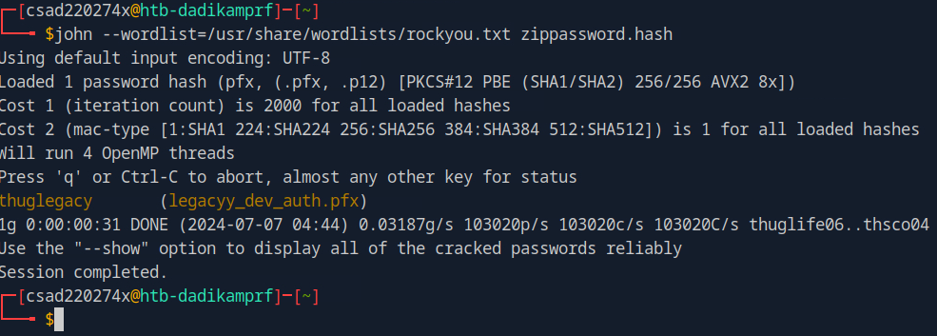

*John the Ripper has successfully obtained the password of ‘thuglegacy’ that allows the file’s contents to be extracted.*

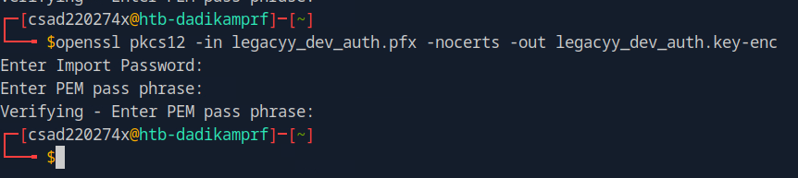

*By returning to extract the keys, the correct password of ‘thuglegacy’ is given and a PEM pass phrase is required. The input for this is ‘1234’. With the key in possession, it can be decrypted with the created password for ease of use:*

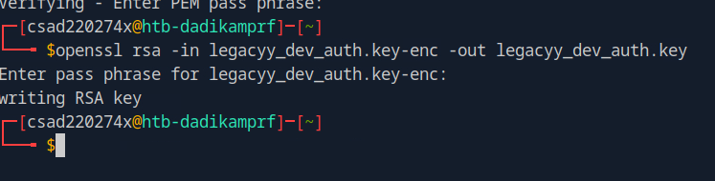

*Now the public key certificate is created to hold that information:*

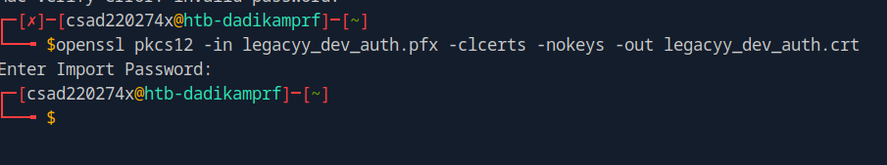

*Now with both public key certificate (legacyy_dev_auth.crt) and private key (legacyy_dev_auth.key) available, evil-winrm can be used to remotely access into the victim machine:*

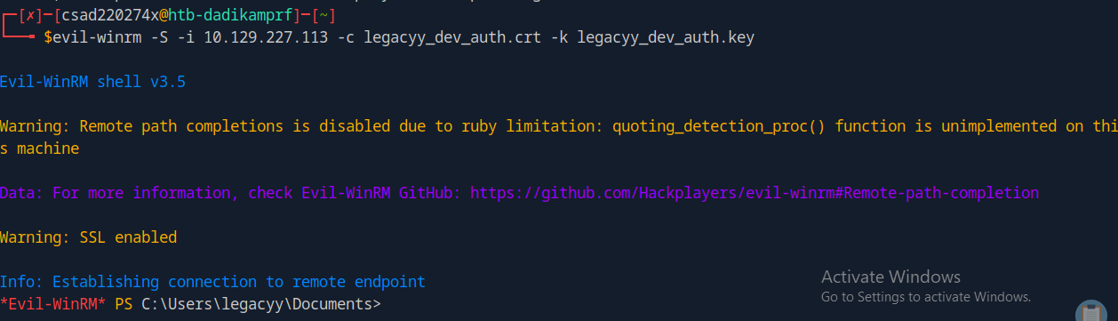

*-S is to enable SSL, -c is to refer to the public key created, -k is for the private key made. With all the credentials correct, remote access into the victim machine is successful. Once in, the directories are explored for files that could be meaningful.*

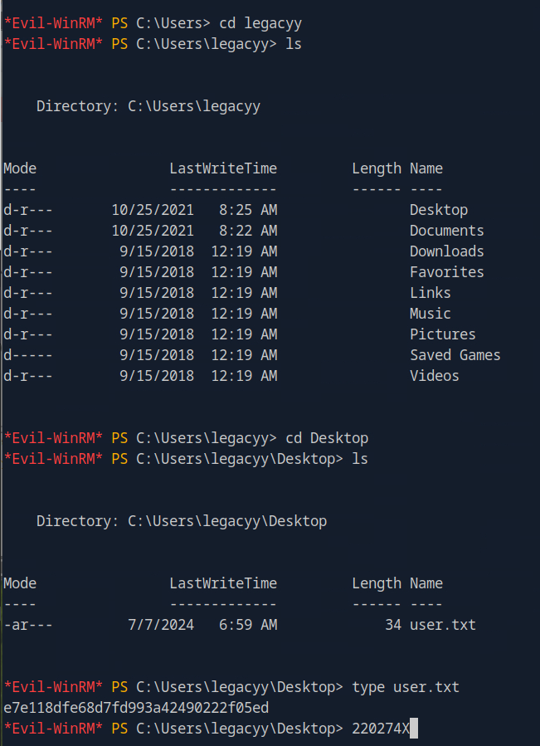

*The C:\Users\legacyy\ directory was explored, and going into the Desktop, a user.txt file was discovered. To read its contents, type [file name] was done to reveal the flag of the Timelapse machine.*

*Flag of Timelapse:* ***e7e118dfe68d7fd993a42490222f05ed***

( 4 marks)

Question 7 (Challenge Question)

Obtain the login credentials found on the machine called ‘**Caving**’.

Using **Nmap**, scan this machine and list the network services running on it.

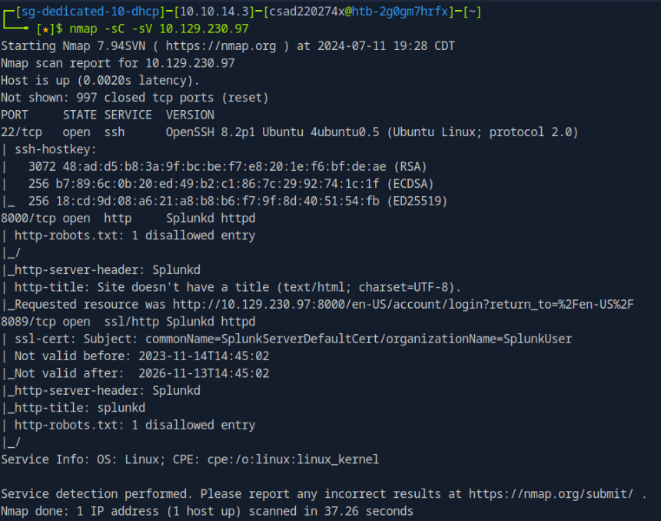

( 1 mark )

What is the web application running on TCP port 8000?

Splunk is running on TCP port 8000

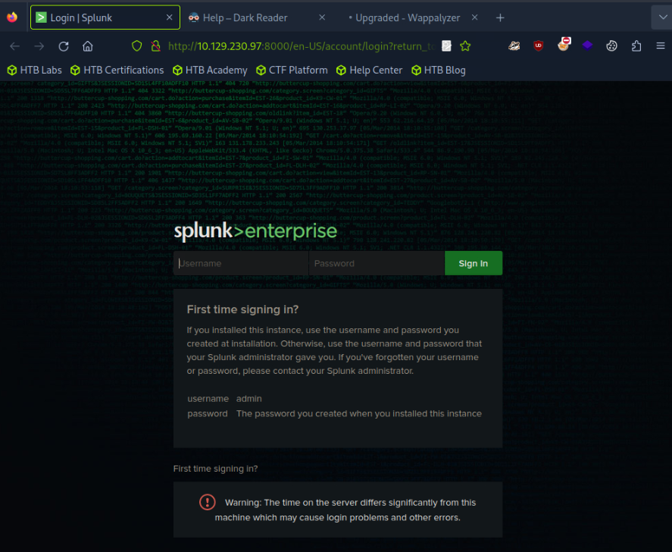

( 1 mark )

Attempt to find the ‘guest’ account login password for the web application

*To attempt to gain access into the splunk web application, the metasploit framework is used with msfconsole:*

*And with the known service that is splunk, possible exploits can be looked up through ‘search splunk’. This gives multiple options and the one chosen is auxiliary/scanner/http/splunk_web_login to use brute to acquire the password for the guest account.*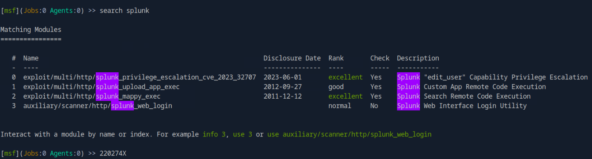

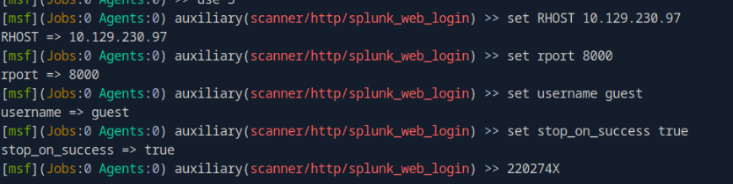

*The above contains the parameters set before running the exploit.*

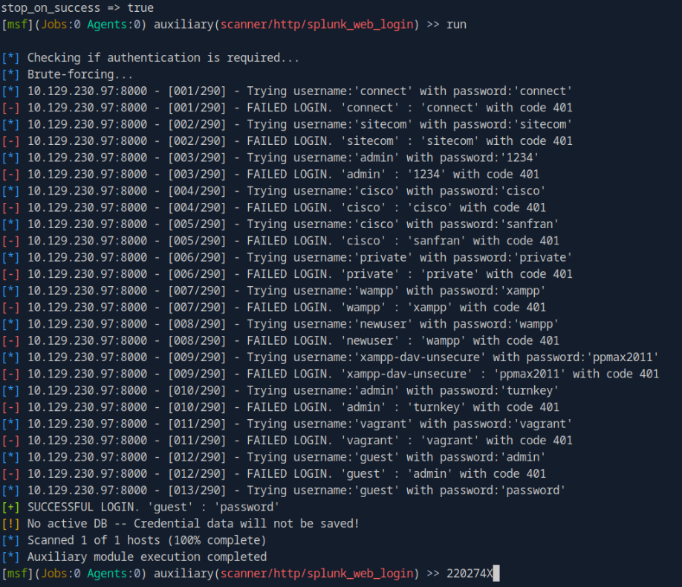

*The brute forcing attempt is successful and has stopped when the correct credentials have been found.*

*Username: guest*

*Password: password*

*To verify, these credentials are entered onto the splunk login page:*

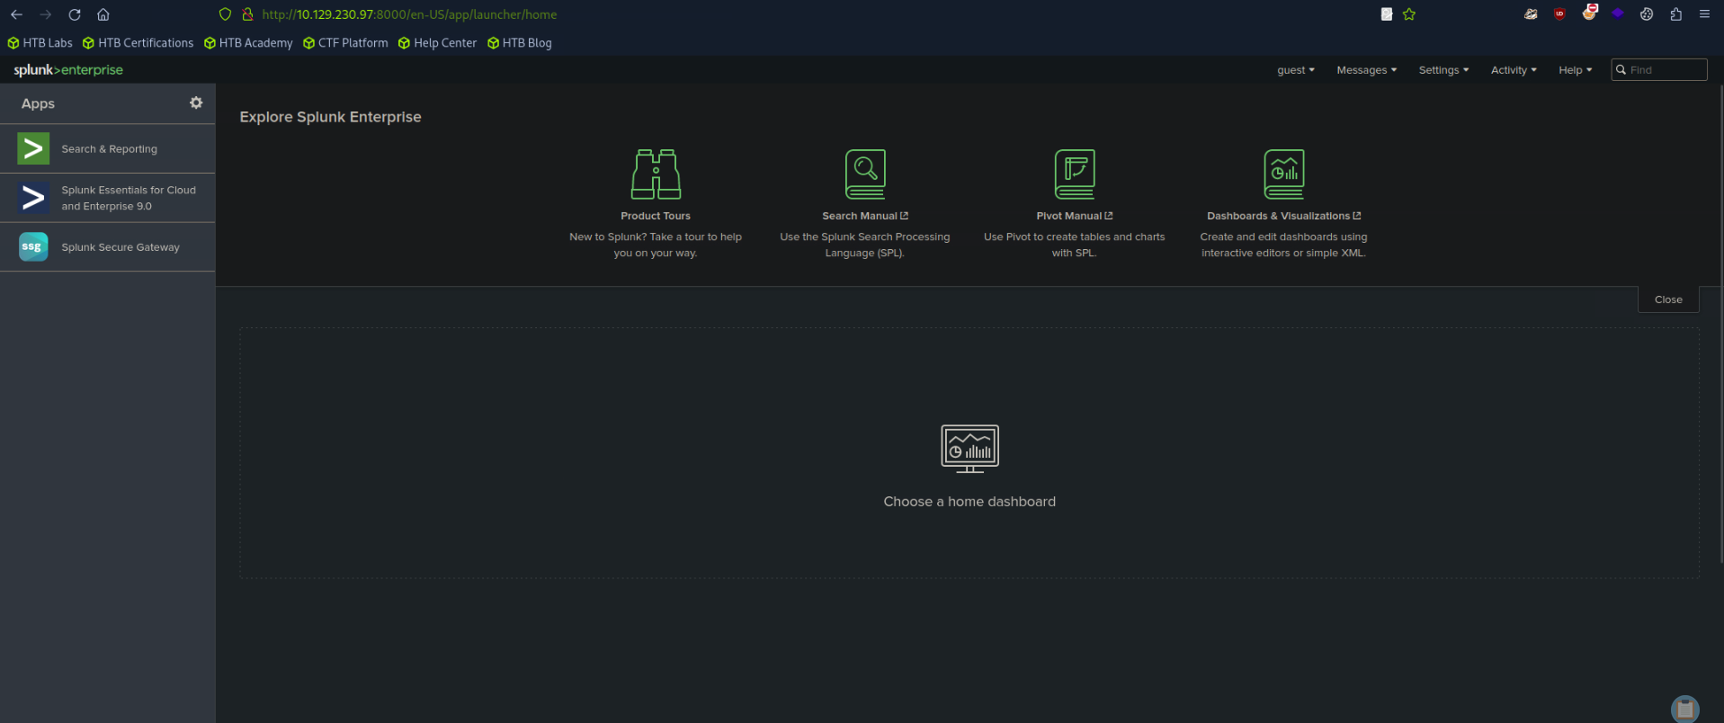

*The credentials are indeed correct and the page can be accessed.*

( 8 marks )

**END OF SECTION A**

**END OF ASSIGNMENT**